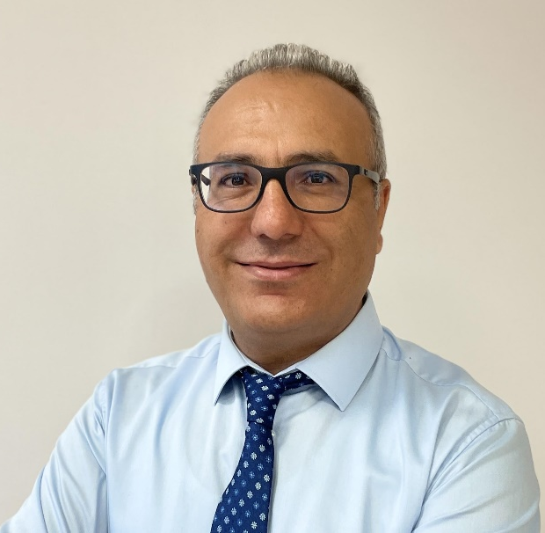

Müslüm Arıcı is a Professor in Thermodynamics and Heat Technique Division of Mechanical Engineering Department of Kocaeli University, Türkiye. He currently serves as the Coordinator of International Relations at Kocaeli University. He has co-authored more than 350 SCI-indexed papers, which have received over 13,500 citations, with an h-index of 65 in Scopus. He has contributed to numerous national and international research projects focusing on sustainable energy, thermal energy storage, and low-carbon building technologies. He is actively engaged in international academic collaborations, conference organizations, and interdisciplinary projects related to sustainable and smart energy systems. He serves as an associate editor for several SCI-indexed journals. He is also co-editor of 3 books. He has been listed among world’s top 2% scientists according to Stanford University in the last five consecutive years. His main research interests include thermal energy storage, solar energy, energy efficient buildings, and thermal management.

Title: Phase Change Material-Based Thermal Energy Storage for Sustainable Energy Systems

